CRUD OPERATION IN SRP

SRP->Single Responsibility Principle:

->Each class or method should handle only one of the operations

->eg:create,read,update,delete.

1.CREATE:

Config.php:

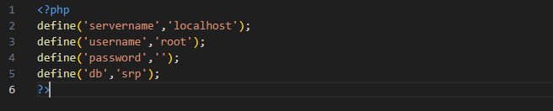

Function.php:

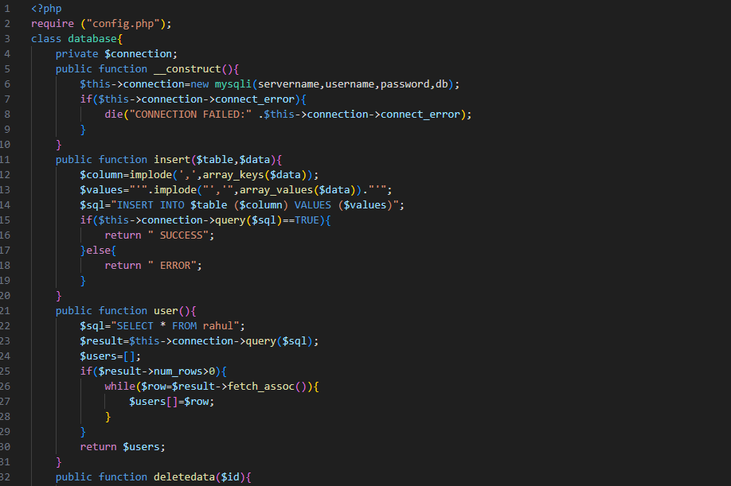

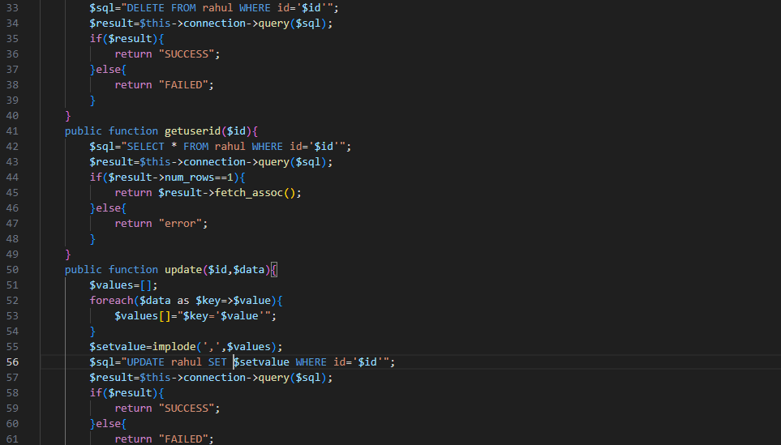



Insert.php:

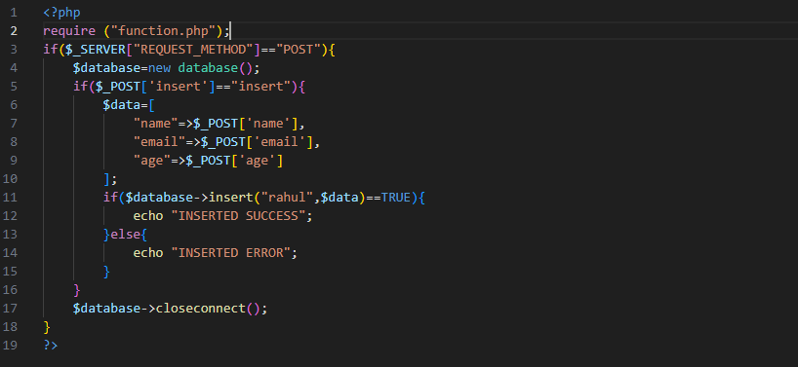

Index.php:

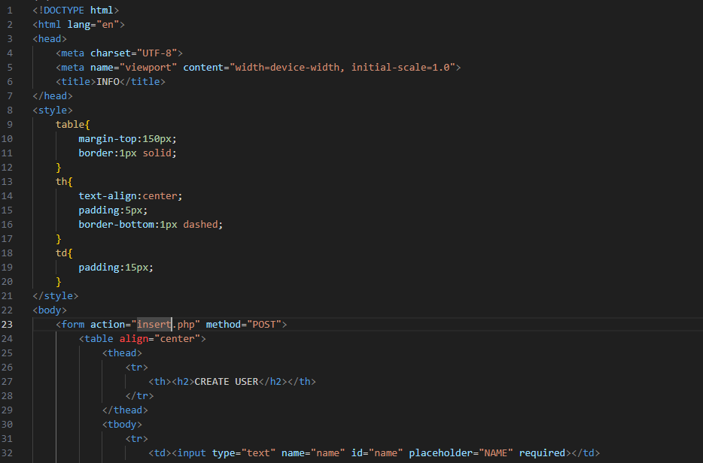

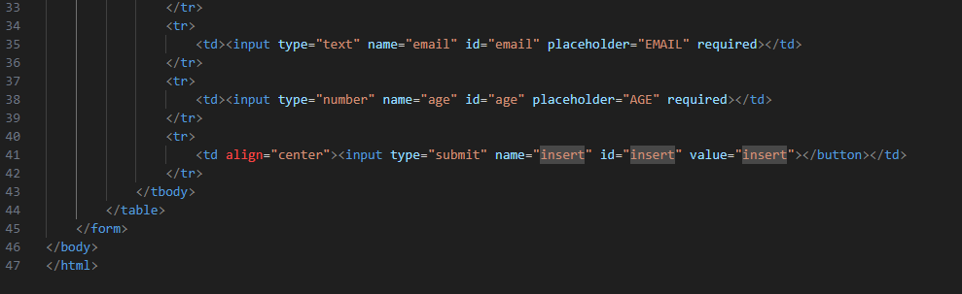

OUTPUT:

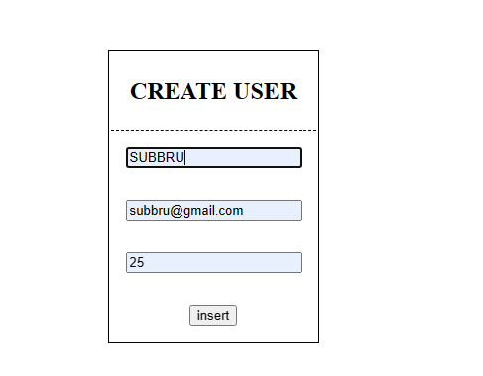

2.READ DATAS FROM DB AND DISPLAY:

Table.php:

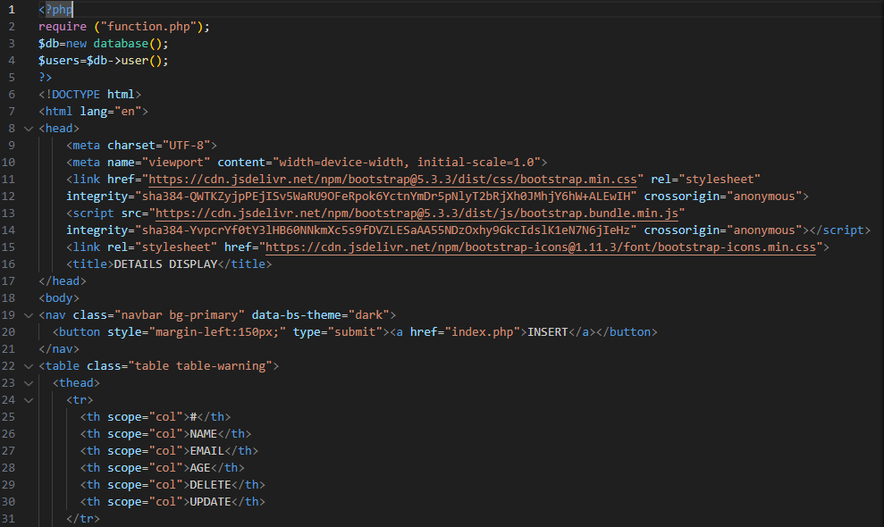

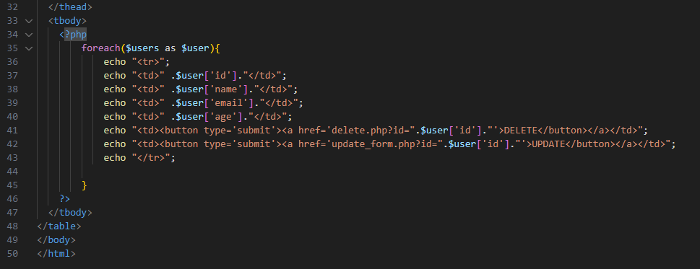

OUPUT:

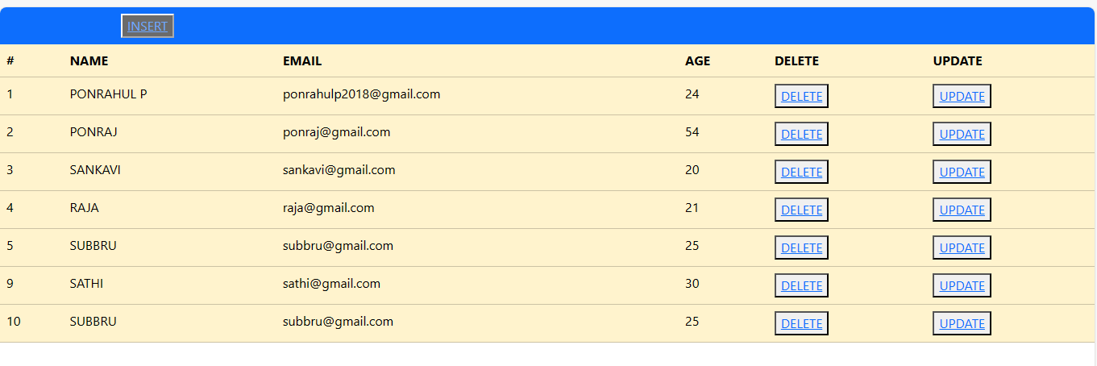

3.DELETE DATAS:

Delete.php:

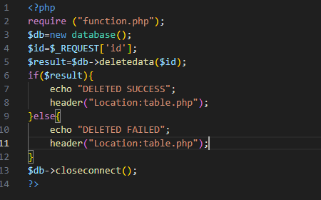

OUTPUT:

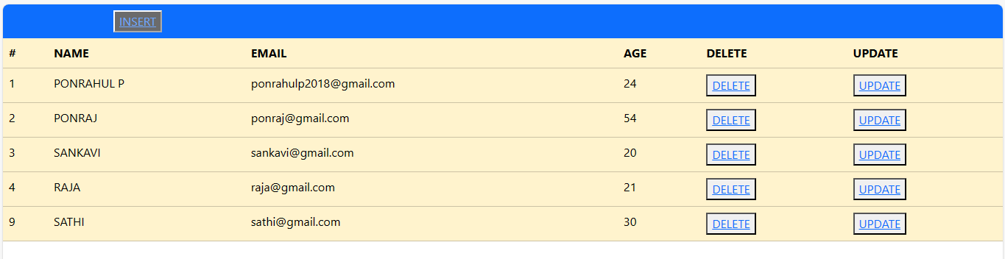

4.UPDATE DATAS:

Update_form.php:

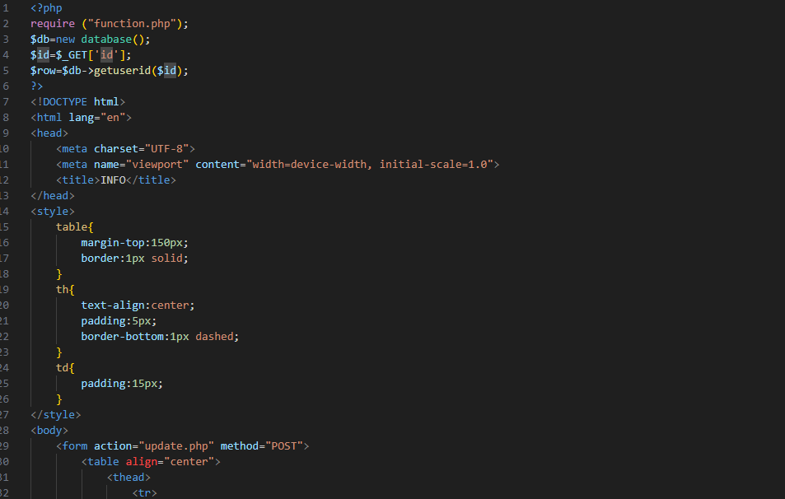

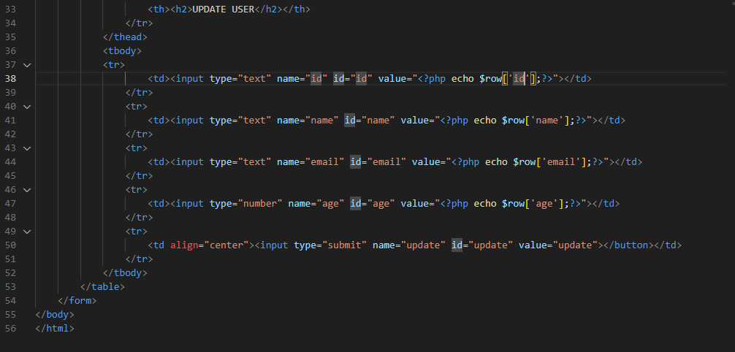

OUTPUT:

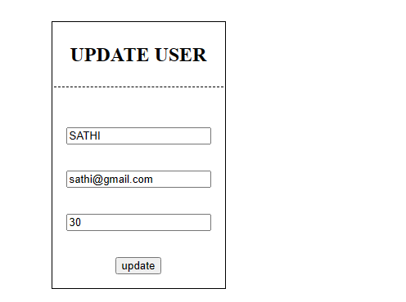

Update.php:

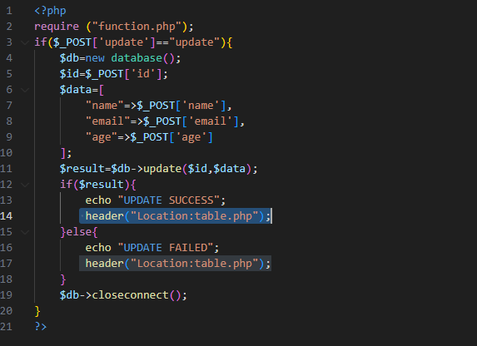

OUTPUT:

